Profile

Name: Fujii Miyuka
family name given name
Nationality: Japan
Birth date: 16/02/2003 (day/month/year)
Age: 14 Sex: female
School (year): Eighth grade in Shiraishi Junior High School

Family (name, age and occupation)
Father: Akihiro,44,office worker
Mother: Manami,45,office worker
Siblings: Yugo, 11, 5th grader

Allergy: None Religion: Buddhist

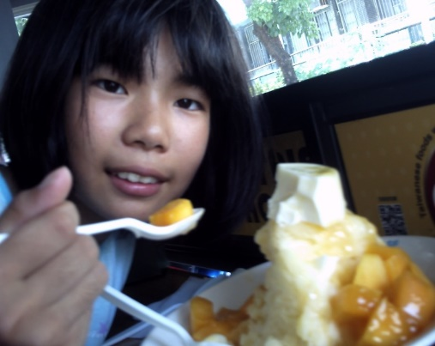

Message
Dear family,
Thank you very much for becoming my host family.
My name is Miyuka Fuji. My family and friends call me Miyu. So please call me Miyu.
I am a member of the table tennis club in my school. And I belong to Boy scouts. I like
reading books and handicraft with ropes, sticks and so on. I like outdoor activities, too.
I am very excited to go to the United States this spring. I would like to see a lot of things and want to know American culture.
I am looking forward to seeing you.
Sincerely,
藤井 美夢花

